# MDay 2 Data Analysis

Source 2:

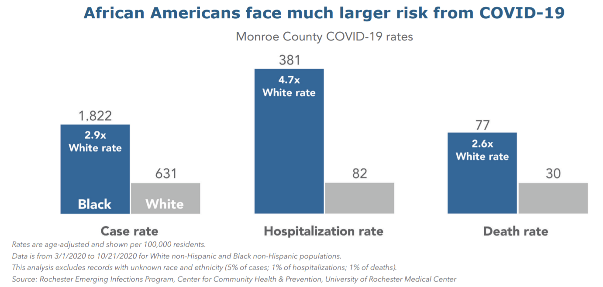

**✎ Make at least three observations on the data presented.**

|  |
| --- |
| The rates are per 100,000 people  More black people get infected by Covid  More black people get killed by covid  Blacks are almost 5x more likely to get hospitalized |

**✎ What story do these statistics tell about people in Monroe County?**

|  |
| --- |
| The rate for Covid infections is greater for black Americans. Also, the rates for hospitalization and deaths are greater for black Americans in Monroe county. I suspect this is because black Americans don’t get the proper resources. |

Source 3:

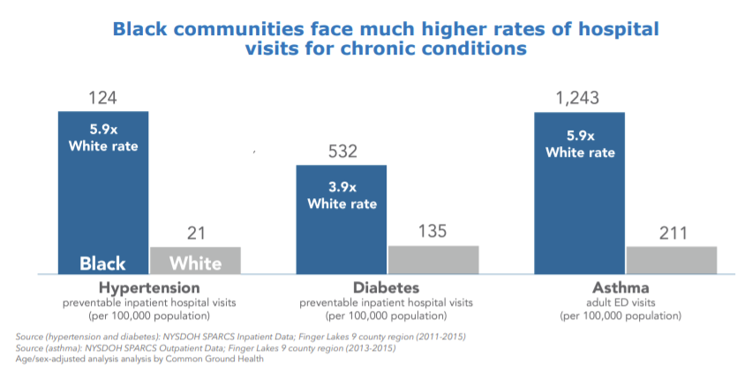

**✎ Make at least three observations on the data presented.**

|  |
| --- |
| Black Americans are almost 6x likely to have hypertension  The rates are per 100,000  Black Americans are more likely to have a physical illness/disease |

**✎ What story do these statistics tell about people in Monroe County?**

|  |
| --- |
| These statistics tell that blacks are more likely to have a disease in Monroe county. |

Source 4:

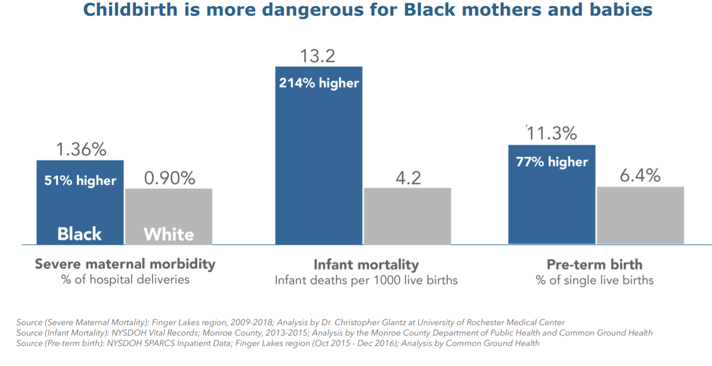

**✎ Make at least three observations on the data presented.**

|  |
| --- |
| Discussing birth rates  Per 1000 live births  More black babies are likely to die |

**✎ What story do these statistics tell about people in Monroe County?**

|  |
| --- |
| These statistics are saying that black babies are more likely to die and be born prematurely |

Source 5:

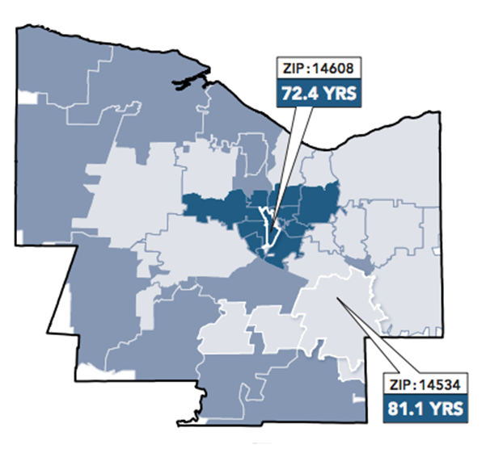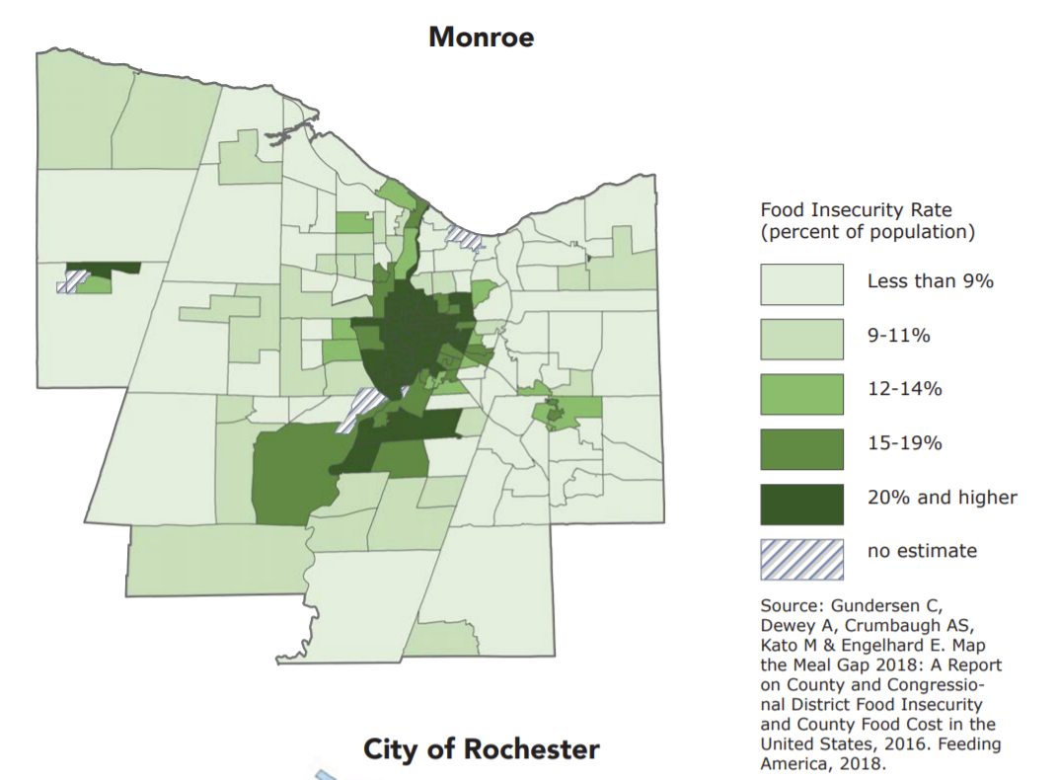

**✎ Make at least three observations on the data presented.**

|  |
| --- |
| The city has the greatest good insecurity rate  The outer areas have lower rates  More blacks live in the city than in the outskirts |

**✎ What story do these statistics tell about people in Monroe County?**

|  |
| --- |
| People who live in the city experience greater food insecurities than in the outskirts |